Boettcher Concert Hall Renovation Analysis
Denver, CO

Project Details
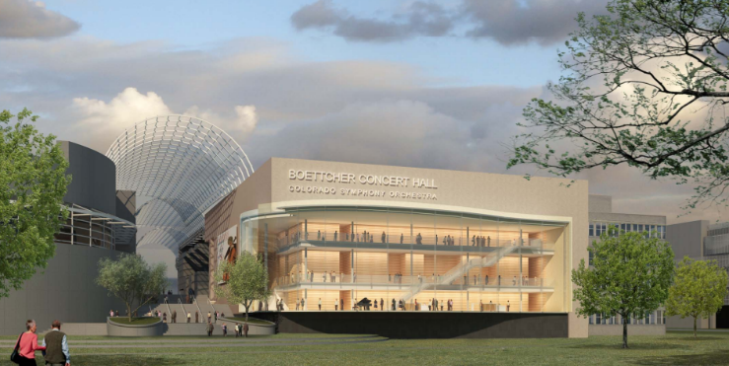
Description: Renovation/Expansion
Owner: City & County of Denver
Architect: Diamond + Schmitt/Oz Architecture
Cost Consultant: Donnell Consultants
Acoustician: Akustiks
Theatre Consultant: Fisher Dachs
Budget: $92.7mm - $150.6mm
Completion: Discovery Phase, April 29, 2009

Project Description
The Boettcher Concert Hall Renovation Project was a City and County of Denver construction project that was to be funded by $60 million of 2007 Cultural Facilities bonds through the Better Denver Bond Program, and at least $30 million in additional funding from the Colorado Symphony Association. The project was managed by a Project Management Team (PMT) comprised of appointed persons from City of Denver Department of Public Works, Theatres and Arenas (now Arts and Venues), and the Colorado Symphony Association. In addition to the PMT, the project team included a Financial Director, Lotte Lieb Dula, who was engaged directly by Theatres and Arenas, and an Owners Representative, Romani Group, Inc.
In July 2008, Diamond + Schmitt Architects and OZ Architecture, a Joint Venture, was selected as the design team for the project and Akustiks was selected as the project acoustician. During the contract negotiations with the design team, it became evident to the PMT that it was necessary to investigate a series of options for the project renovation, as a vetted program and achievable budget had not yet been developed by the stakeholders. The project team ultimately investigated four options (A-D) over a 9-month period in a study termed the Discovery Phase, and the collective group of consultants were contractually engaged for just this preliminary phase of design investigation. The four options included minor and major renovations of the existing building (A and B), a new building (C), and a major renovation that incorporated the adjacent building, 1245 Champa Street, into the project (D). Ultimately and unfortunately, the project did not proceed beyond the Discovery Phase, as the Symphony was unable to raise the necessary funds to meet their obligations to the City.
Scope of Work
While at Romani Group, Eric Shafran served as the Project Manager for the duration of the Discovery Phase, performing the following duties:
- Ongoing development and management of the overall project budget and schedule;
- Management of architectural teams in Toronto and Denver, and close coordination of renovation details with architectural subconsultants;
- Administration of RFQ-P processes for acoustician and cost consultant, and negotiation and management of their contracts;
- Analysis and take-off of FF&E, including specialized performance hall-related equipment;
- Negotiation, engagement and management of contracts with consultants in the fields of environmental remediation and survey;
- Preparation of all Discovery Phase deliverables and presentation materials.

